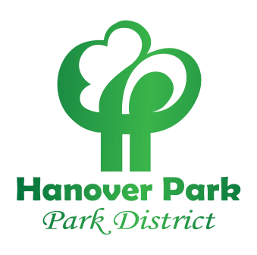
HANOVER PARK PARK DISTRICT
Board of Commissioners
Community Center
1919 Walnut Ave, Hanover Park, Il 60133
Telephone: (630)837-2468 or info@hpparks.org

SPECIAL BOARD MEETING AGENDA

BOARD OF COMMISSIONERS SPECIALL MEETING AGENDA, COMMUNITY CENTER BOARD ROOM, 1919 WALNUT AVE, HANOVER PARK, IL, 60133. THURSDAY, MARCH 26, 2026 7:30 P.M.

- CALL MEETING TO ORDER

- ROLL CALL

- APPROVAL OF THE AGENDA

- PUBLIC COMMENT

5. NEW BUSINESS
A. DISCUSSION – Draft Budget Summary Statement

6. ADJOURNMENT

